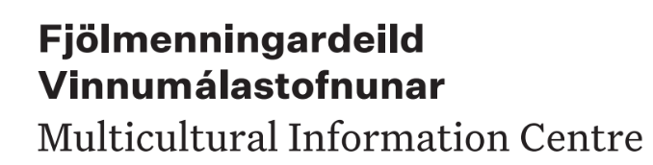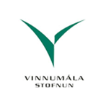

2025

English

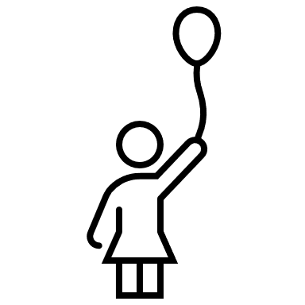

Children and Young People

Information for people who have just been granted the status of refugees in Iceland

Children and their rights
People under the age of 18 are classed as children. They are legal minors (they are not able to take on responsibilities according to law) and their parents are their guardians. Parents have a duty to look after their children, care for them and treat them with respect. When parents make important decisions for their children, they should listen to their views and respect them, in accordance with the children’s age and maturity. The older the child is, the more their opinions should count.
- Children have the right to spend time with both their parents, even if the parents do not live together.
- Parents have a duty to protect their children against disrespectful treatment, mental cruelty and physical violence. Parents are not allowed to act violently towards their children.
- In Iceland, all corporal punishment of children is prohibited by law — including by parents and caregivers. If you come from a country where corporal punishment is considered acceptable, please note that it is not allowed in Iceland and may lead to investigation by child protection authorities. It is important to use parenting methods that are safe, respectful, and in accordance with Icelandic law. If you need more information or support, please contact the social services in your municipality.
- Parents have a duty to provide their children with housing, clothes, food, school equipment and other necessary items.
- According to Icelandic law, female genital mutilation is strictly prohibited, regardless of whether it is carried out in Iceland or abroad. The sentence it carries can be up to 16 years in prison. Both the attempted crime, as well as the participation in such an act, is also punishable. The Law is applicable to all Icelandic citizens, as well as those residing in Iceland, at the time of the crime.
- Children may not be married in Iceland. Any marriage certificate that shows that one or both persons in a marriage were under the age of 18 at the time of the marriage is not accepted as valid in Iceland.
- Here you can find information about different types of violence, along with guidance for parents whose children experience or show violent behaviour.
Advice for parents to prevent youth violence
Violence against children | Lögreglan

For more information about children’s rights in Iceland, see:
- https://www.barn.is/born-og-unglingar/rettindi-barna-og-unglinga/
- https://www.island.is/born

Preschool
- Preschool (kindergarten) is the first stage of the school system in Iceland and is for children aged 6 and younger. Preschools follow a special programme (National Curriculum Guide).
- Preschool is not compulsory in Iceland, but about 96% of children aged 3-5 attend preschool.
- Preschool staff are professionals who are trained to teach, educate, and care for children. A lot of effort is put into making them feel good and developing their talents to the maximum, according to each one needs.
- Children in preschool learn by playing and making things. These activities lay the basis for their education in the next level of school. Children who have been through preschool are better prepared for learning in junior (compulsory) school. This is particularly true in the case of children who do not grow up speaking Icelandic at home: they learn it in preschool.
- Preschool activities give children whose mother tongue (first language) is not Icelandic a good grounding in Icelandic. At the same time, the parents are encouraged to support the child’s first-language skills and learning in various ways.
- Preschools try, as far as they can, to ensure that important information is presented in other languages for the children and their parents.
- Parents must register their children for preschool places. You do this on the on-line (computer) systems of the municipalities (local authorities; for example, Reykjavík, Kópavogur). For this, you must have an electronic ID.
- The municipalities subsidise (pay a large part of the cost of) preschools, but preschools are not completely free of charge. The cost for each month is slightly different from one place to another. Parents who are single, or are studying or who have more than one child attending preschool, pay a smaller charge.
- Children in preschool play outside on most days, so it is important that they have proper clothing according to the weather (cold wind, snow, rain or sun). http://morsmal.no/no/foreldre-norsk/2382-kle-barna-riktig-i-vinterkulda
- Parents stay with their children at preschool on the first few days to help them to get used to it. There, the parents are given all the most important information.
- For more about preschools in several languages, see the Reykjavík City website: https://mml.reykjavik.is/2019/08/30/baeklingar-fyrir-foreldra-leikskolabarna-brouchures-for-parents/
Junior school (grunnskóli; compulsory school, up to age 16)
- By law, all children in Iceland aged 6-16 must go to school.
- All schools work according to the National Curriculum Guide for Compulsory Schools, which is set by the Althingi (parliament). All children have an equal right to attend school, and the staff try to make them feel well at school and make progress with their school work.
- Junior school in Iceland is free of charge.
- School meals are free of charge.
- All junior schools follow a special programme to help children adapt (fit in) at school if they do not speak Icelandic at home.
- Children whose home language is not Icelandic have the right to be taught Icelandic as their second language. Their parents are also encouraged to help them learn their own home languages in various ways.
- The junior schools try, as far as they can, to ensure that information that is important for contact between teachers and parents is translated.
- Parents must register their children for junior school and after-school activities. You do this on the on-line (computer) systems of the municipalities (local authorities; for example, Reykjavík, Kópavogur). For this, you must have an electronic ID.
- Most children go to the local junior school in their area. They are grouped in classes by age, not by ability.
- Parents have a duty to tell the school if a child is ill or has to miss school for other reasons. You must ask the head teachers, in writing, for permission for your child not to attend school for any reason.
- https://mml.reykjavik.is/bruarsmidi/

Junior school, after-school facilities and social centres
- Sports and swimming are compulsory for all children in Icelandic junior schools. Normally, boys and girls are together in these lessons.
- Pupils (children) in Icelandic junior schools go outside twice a day for short breaks so it is important for them to have proper clothes for the weather.
- It is important for children to bring healthy snack food to school with them. Sweets are not permitted in junior school. They should bring water to drink (not fruit juice). In most schools, children can have hot meals at lunch time. Parents must pay a small charge for these meals.
- In many municipal areas, pupils can have help with their homework, either in school or in the local library.
- Most schools have after-school facilities (frístundaheimili) offering organised leisure activities for children aged 6-9 after school hours; you must pay a small charge for this. The children have a chance to talk to each other, make friends and learn Icelandic by playing together with others.
- In most areas, either in the schools or close to them, there are social centres (félagsmiðstöðvar) offering social activities for children aged 10-16. These are designed to involve them in positive social interaction. Some centres are open in the late afternoon and evening; others in school breaktime or the lunch break in school.

Schools in Iceland – traditions and customs
Junior schools have school councils, pupils’ councils and parents’ associations to look after pupils’ interests.
- Some special events take place during the year: parties and trips that are organised by the school, the pupils’ council, the class representatives or the parents’ association. These events are advertised specially.
- It is important that you and the school communicate and work together. You will meet the teachers twice each year to talk about your children and how they are doing in school. You should feel free to contact the school more often if you want to.
- It is important that you (the parents) come to class parties with your children to give them attention and support, see your child in the school environment, see what goes on in the school and meet your children’s classmates and their parents.
- It is common that the parents of children who play together also have a lot of contact with each other.
- Birthday parties are important social events for children in Iceland. Children who have birthdays close together often share a party so as to be able to invite more guests. Sometimes they invite only girls, or only boys, or the whole class, and it is important not to leave anyone out. Parents often make an agreement about how much presents should cost.
- Children in junior schools do not normally wear school uniforms.

Sports, arts and leisure activities
It is considered important that children take part in leisure activities (outside school hours): sports, arts and games. These activities play a valuable part in preventive measures. You are urged to support and help your children to take an active part with other children in these organised activities. It is important to find out about the activities on offer in your area. If you find the right activity for your children, this will help them to make friends and give them a chance to get used to speaking Icelandic. Most municipalities give grants (money payments) to make it possible for children to follow leisure activities.
- The main aim of the grants is to make it possible for all children and young people (aged 6-18) to take part in positive after-school activities no matter what sort of homes they come from and whether their parents are rich or poor.
- The grants are not the same in all municipalities (towns) but are ISK 35,000 – 50,000 per year per child.
- Grants are paid electronically (online), directly to the sports or leisure club involved.
- In most municipalities, you must register in the local online system (e.g. Rafræn Reykjavík, Mitt Reykjanes or Mínar síður in Hafnarfjörður) to be able to register your children for school, preschool, leisure activities, etc. For this, you will need an electronic ID (rafræn skilriki).

Upper secondary school (framhaldsskóli)
- Upper secondary school prepares pupils for going out to work or going on with further studies. Framhaldsskólar á landinu
- Upper secondary school is not compulsory but those who have completed junior (compulsory) school and passed the junior school examination or equivalent, or have turned 16, can begin upper secondary school. Innritun í framhaldsskóla
- For more information, see: https://www.island.is/framhaldsskolar
Rules on children out of doors
The law in Iceland says how long children aged 0-16 may be outside in the evenings without adult supervision. These rules are intended to ensure that children will grow up in a safe and healthy environment with sufficient sleep.
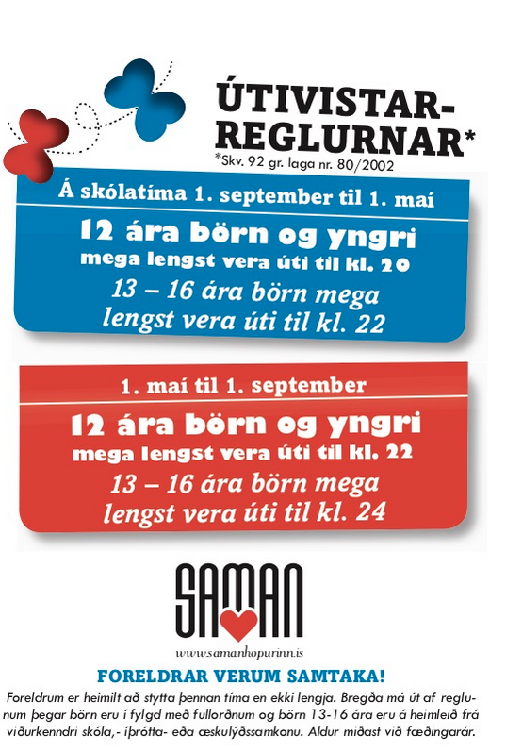
Parents let’s work together!
Outdoor hours for children During the school period (From 1st September until 1st May)
Children, 12 years old or younger, may not be outside their home after 20:00 pm.
Children, 13 to 16 years of age, may not be outside their home after 22:00 pm. During the summer (From 1st May until 1st September)
Children, 12 years old or younger, may not be outside their home after 22:00 pm.
Children, 13 to 16 years of age, may not be outside their home after 24:00 pm.
www.samanhopurinn.is

Parents and caregivers have absolute rights to reduce these outdoor hours. These rules are in accordance with the Icelandic Child Protection laws and forbid children to be in public places after the stated hours without adult supervision. These rules can be exempted if children 13 to 16 years of age are on their way home from an official school, sports, or a youth centre’s activity. The child’s birth year rather than its birthday applies.
The Prosperity Act (Farsæld barna)
In Iceland, a new law has been introduced to support children's well-being. It is called the Act on Integrated Services in the Interest of Children’s Prosperity — also known as the Prosperity Act.
This law ensures that children and families don’t get lost between different systems or have to navigate services on their own. Every child has the right to receive the help they need, when they need it.
Finding the right support can sometimes be difficult, and this law aims to make it easier by ensuring that the right services are provided, at the right time, by the right professionals. Children and parents can request integrated services at all school levels, through social services, or at health clinics.
You can learn more about the Prosperity act here: https://www.farsaeldbarna.is/en/home.

Support for Children from Municipal Social Services
- Educational counsellors, psychologists, and speech therapists at the Municipal School Service offer advice and support to parents of children in preschool and compulsory school.
- Parents and children can receive guidance and assistance in dealing with difficult situations, such as financial hardship, parenting challenges, or social isolation at their local Social Services
- You can apply to the Social Services for financial assistance to help cover costs such as preschool fees, after-school programs, summer camps, or sports and leisure activities.
Please note that the amount of support available may vary depending on your municipality.
- NB Each application is reviewed individually, and every municipality has its own rules for granting financial support.

Child Protection Services in Iceland
- Municipalities in Iceland are responsible for child protection and must follow national child protection laws.
- Child protection services are available in all municipalities. Their role is to support children and parents facing serious challenges and to ensure the child’s safety and well-being.
- Child protection workers are specially trained professionals, often with backgrounds in social work, psychology, or education.
- If needed, they can receive additional support and guidance from the National Agency for Children and Families (Barna- og fjölskyldustofa), especially in complex cases.
In some situations, local district councils have the authority to make formal decisions in child protection matters.

Duty to Report
Everyone has a legal obligation to contact child protection services if they suspect that a child:
a) is living in unacceptable conditions,
b) is being subjected to violence or degrading treatment, or
c) is at serious risk of harm to their health or development.
This duty also applies if there is reason to believe that the health, life, or development of an unborn child may be seriously at risk due to the lifestyle, behaviour, or circumstances of the expecting parents — or for any other reason that may concern child protection services.
Child protection services in Iceland are primarily focused on support and cooperation with families. This means, for example, that a child is not removed from their parents unless all other efforts to strengthen the family and improve parenting have proven unsuccessful.
According to the UN Convention on the Rights of the Child, a child should not be separated from their parents unless it is necessary for the child’s well-being and in their best interests.

Child benefit
- Child benefit is an allowance (money payment) from the tax authorities to parents (or single/divorced parents) for the children registered as living with them.
- Child benefit is income related. This means that if you have low wages, you will receive higher benefit payments; if you earn more money, the benefit amount will be smaller.
- Child benefit is paid out 4 times per year, please check the link
Child benefits | Skatturinn - skattar og gjöld
- After a child is born or moves to their legal home (lögheimili) in Iceland, a certain time may pass before their parents receive child benefit. You can check with the social services office in your home country.
- Refugees can apply for extra payments from Social Services to cover make up the full amount. You must remember that all applications are considered separately, and each municipality has its own rules that must be followed when benefit payments are made.

The Social Insurance Administration (TR) – Financial Support for Children
Child support (meðlag) is a monthly payment made by one parent to the other when they do not live together (e.g. after separation or divorce). The child is registered as living with one parent, and the other parent pays. These payments legally belong to the child and must be used for their care.
You can request that the Social Insurance Administration (Tryggingastofnun ríkisins, TR) collect and transfer the payments to you. When you apply for child support you must submit the child’s birth certificate.
Child pension (barnalífeyrir) is a monthly payment from TR if one of the child’s parents has died or is receiving an old-age pension, disability benefit, or rehabilitation pension. A certificate or report from the UN Refugee Agency (UNHCR) or the Immigration Agency must be submitted to confirm the parent’s situation.
Mother’s or father’s allowance is a monthly payment from TR to single parents with two or more children legally domiciled with them.
Applications for child-related benefits now available on Island.is
You can now apply for child-related benefits directly through Island.is for various child-related benefits, such as:
- Child pension
https://island.is/en/application-for-child-pension
- Death benefits in the event of loss of a spouse
https://island.is/en/benefit-after-the-death-of-a-partner
- Education grants
https://island.is/en/parents-contribution-for-education-or-vocational-training
- Child support
https://island.is/en/child-support/request-for-a-ruling-on-child-support
- Childcare allowance for chronically ill or disabled children
https://island.is/en/care-allowance
- Parental allowance for children with chronic or several disabilities
https://island.is/en/parental-allowance-with-children-with-chronic-or-severe-illness
- Home supplement for those receiving pension or allowance and live alone
https://island.is/heimilisuppbot

Useful information
Umboðsmaður barna (The Children’s Ombudsman) works to ensure that children’s rights and interests are respected. Anyone can apply to the Children’s Ombudsman, and questions from children themselves always receive priority.
Tel.: 522-8999
Children’s phone line – free of charge: 800-5999
E-mail: ub@barn.is
Ráðgjafa og greiningastöð (The Consulting and Analysis Center) The role of the Counseling and Diagnostic Center is to ensure that children with severe developmental disabilities that may lead to disability later in life receive diagnosis, counseling, and other resources that improve their quality of life.
Tel: 510-8400
Email: rgr@rgr.is

Landssamtökin Þroskahjálp Throskahjalp focuses on being proactive in consultation, advocacy, and monitoring of the rights of persons with disabilities
Tel: 588-9390
Email: throskahjalp@throskahjalp.is

Barna og fjölskyldustofa (The National Agency for Children and Families) The agency handles child protection matters throughout the country. Its role is to provide and support services based on the best knowledge and practices at any given time. Barnahus children´s center is part of the agency and their role is to handles cases of children suspected of being sexually assaulted or abused. The Child Protective Services are responsible for handling such cases, and can also seek and request services from Barnahús on suspicion of other forms of violence against children. The Barnahús Children’s Center also provides education on sexual abuse, among other things, for parties working with children.
Tel: 530-2600
Email: bofs@bofs.is

Við og börnin okkar – Our children and us – Information for families in Iceland (in Icelandic and English).

